PoE Switch

🔌 What is a PoE Switch?
# Source: Chatgpt (GPT‑5 Mini) at [12/18/2025]
A PoE Switch (Power over Ethernet Switch) is a network switch that not only transfers data, but also delivers electrical power to connected devices through the same Ethernet cable.
It allows you to power devices like:
- IP cameras
- VoIP phones
- Wireless Access Points (WAPs)
- IoT sensors
without needing separate power adapters or outlets.

⚙️ How PoE Works
# Source: Chatgpt (GPT‑5 Mini) at [12/18/2025]
Normally, an Ethernet cable carries only data. With PoE, the switch injects DC power into the same cable, allowing devices to receive both data and power through a single line.
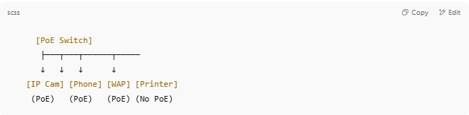
[PoE Switch]
├───┬───┬──────┬─────
↓ ↓ ↓ ↓
[IP Cam] [Phone] [WAP] [Printer]
(PoE) (PoE) (PoE) (No PoE)

- Devices like printers that don’t support PoE just receive data — safely.

🔧 Key Features of a PoE Switch
# Source: Chatgpt (GPT‑5 Mini) at [12/18/2025]
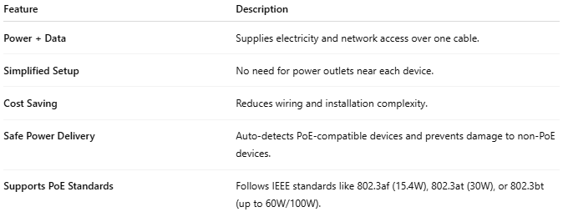
Feature | Description
Power + Data | Supplies electricity and network access over one cable.
Simplified Setup | No need for power outlets near each device.
Cost Saving | Reduces wiring and installation complexity.
Safe Power Delivery | Auto-detects PoE-compatible devices and prevents damage to non-PoE devices.
Supports PoE Standards | Follows IEEE standards like 802.3af (15.4W), 802.3at (30W), or 802.3bt (up to 60W/100W).

🆚 PoE vs Regular Switch
# Source: Chatgpt (GPT‑5 Mini) at [12/18/2025]
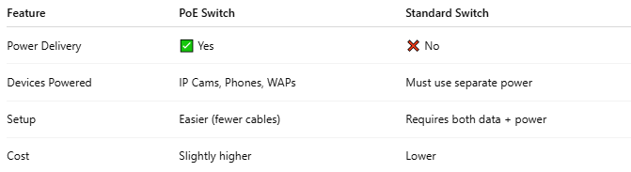
Feature | PoE Switch | Standard Switch
Power Delivery | ✅ Yes | ❌ No
Devices Powered | IP Cams, Phones, WAPs | Must use separate power
Setup | Easier (fewer cables) | Requires both data + power
Cost | Slightly higher | Lower

🧱 Types of PoE Switches
# Source: Chatgpt (GPT‑5 Mini) at [12/18/2025]
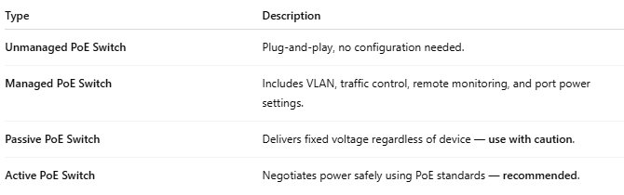
Type | Description
Unmanaged PoE Switch | Plug-and-play, no configuration needed.
Managed PoE Switch | Includes VLAN, traffic control, remote monitoring, and port power settings.
Passive PoE Switch | Delivers fixed voltage regardless of device — use with caution.
Active PoE Switch | Negotiates power safely using PoE standards — recommended.

🔌 Power Budget Example
# Source: Chatgpt (GPT‑5 Mini) at [12/18/2025]
If your switch supports 120W PoE power, you can power:
- 4 x IP Cameras @ 15W = 60W
- 2 x Access Points @ 25W = 50W
- Total = 110W used (within budget)
Always check the PoE budget to ensure you don’t exceed it.

